

**"Criminal Record Management"**

**Project Report**

**Submitted in partial fulfilment of the**

**Requirement for the award of the Degree of**

**BACHELOR OF SCIENCE (COMPUTER SCIENCE)**

**By**

**Manish Lalchand Pal**

**Under the esteemed guidance of**

**Dr. PRAKASH NAIK**

**Head of Department**

**DEPARTMENT OF COMPUTER SCIENCE**

**SMT.SUSHILADEVI DESHMUKH COLLEGE OF ARTS, SCIENCE**

**AND COMMERCE**

**(Aliased to University of Mumbai)**

**AIROLI, NAVI MUMBAI 400708**

**MAHARASHTRA**



**SMT. SUSHILADEVI DESHMUKH COLLEGE OF ARTS, SCIENCE AND**

**COMMERCE, Airoli, Navi Mumbai – 400708**

**DATE:______________**

**Certificate of Completion**

**This is to certify that the project entitled "Criminal Record Management", undertaken by Mr. Manish Lalchand Pal, with seat number __________, in partial fulfilment of the T.Y.B.Sc.**

**CS (Bachelor of Science in Computer Science) degree (Semester V) Examination, has not**

**been submitted for any other examination and does not form part of any other course**

**undergone by the candidate.**

**It is further certified that Mr. Manish Lalchand Pal has completed all required**

**phases of the project.**

**Signature of Internal Guide Signature of HOD**

**Signature of External Principal**

**College Seal**

**PROJECT PROPOSAL**

|  |  |
| --- | --- |
| **1. PRN** | **2021016400387681** |
| **2. Roll No** | **17** |
| **3. Name of the Student** | **Manish Lalchand Pal** |
| **4. Title of the project** | **Criminal Record Management** |
| **5. Name of the guide** | **Prof. Prakash Naik** |
| **6. Is this your first submission?** | **YES** |

**Signature of the Student Signature of the Guide**

**Preface**

As I pen down this preface, I am filled with a sense of accomplishment and pride in presenting the "**Criminal Record Management**" project. This endeavor stems from a fervent desire to contribute to the advancement of law enforcement operations, leveraging the power of technology to streamline processes and enhance community safety.

The conception of this project arose from the recognition of the challenges faced by law enforcement agencies in managing criminal records, handling FIRs, and ensuring effective communication within their departments. The "**Criminal Record Management**" aims to address these challenges by providing a comprehensive digital platform that facilitates efficient criminal record management, online FIR filing, and transparent case tracking.

This project represents not just a culmination of technical skills and knowledge but also a commitment to the betterment of our society. As technology continues to play a pivotal role in shaping the future, it is our responsibility to harness its potential for the greater good. The "**Criminal Record Management**" embodies this ethos, aiming to contribute to the modernization of law enforcement practices.

I extend my sincere gratitude to all those who have been a part of this journey, especially my project guide, **Prof. Dr. Prakash Naik**, whose guidance and mentorship have been invaluable. His expertise and encouragement have been the guiding force behind the development and success of this project.

I also express my heartfelt thanks to our Principal, **Dr. Shalini Vermani**, whose unwavering support and encouragement have been a constant source of inspiration. Her commitment to fostering innovation and academic excellence has been instrumental in shaping the environment that nurtures projects like this.

I hope that the "**Criminal Record Management**" contributes meaningfully to the realm of law enforcement technology and serves as a testament to the potential of collaborative efforts in addressing societal challenges.

- ***Manish Pal***

## Acknowledgment

I would like to express my sincere gratitude to **Prof. Dr. Prakash Naik**, my project guide, for his invaluable guidance, unwavering support, and profound insights throughout the development of the "**Criminal Record Management.**" His expertise and mentorship have been instrumental in shaping the project and enhancing my understanding of the subject matter.

I extend my heartfelt thanks to **Dr. Shalini Vermani**, our esteemed Principal, for her continuous support and encouragement. Her vision and commitment to academic excellence have provided the foundation for innovative projects like this.

I am also grateful to all the faculty members who have contributed to my learning experience during the course of this project. Their feedback and constructive criticism have played a crucial role in refining the project.

My sincere thanks to my classmates and friends who have been a constant source of motivation and support throughout this journey.

This project would not have been possible without the collective effort and encouragement of everyone involved. Each contribution, big or small, has played a role in shaping the "**Criminal Record Management**" into what it is today.

Thank you.

- **Manish Pal**

**Declaration**

I, **Manish Lalchand Pal**, hereby declare that I am a student pursuing BSc in

Computer Science for the academic year **2023-2024**. The work presented in this project

documentation, titled "**Criminal Record Management**" is entirely my own eort and

creation, under the guidance of **Prof. Dr. Prakash Naik**.

I arm that all aspects of this project, including its conception, design, development, and

documentation, represent my independent work. Any sources of information, references,

or contributions from external parties have been duly acknowledged and cited.

I further declare that this project has been undertaken in accordance with the academic

regulations and ethical standards set by **Mumbai University** and adheres to the principles

of academic integrity.

I acknowledge that any form of plagiarism or academic misconduct is a breach of these

principles and could result in academic penalties. I have taken care to ensure that this

project is a genuine and original endeavor that reflects my dedication and commitment to

the field of Computer Science.

**Date:**

**Signature:**

**Table of Contents**

1. **Introduction**
   * Project Title
   * Identification of Need
2. **Project Objectives**
   * Scope
   * Key Features
3. **Technology Stack**
   * Framework
   * Database
   * Front-End
4. **System Architecture**
   * Database Schema
   * User Interfaces
5. **User Roles and Permissions**
6. **System Functionality**
   * User Registration and Authentication
   * Online FIR Filing
   * Viewing and Tracking FIRs
   * Criminal Record Management
   * Admin Panel
7. **Implementation Details**
   * Flask Application Structure
   * Database Setup
   * Front-End Development
8. **Security Measures**
9. **Conclusion**

* Achievements
* Future Enhancements

1. **References**

## Introduction

### Project Title

The "**Criminal Record Management**" is a modern solution designed to streamline the operations of law enforcement agencies, allowing for efficient criminal record management, online FIR filing, and case tracking.

## Identification of Need - Criminal Record Management

### Background

Law enforcement agencies are tasked with maintaining accurate and accessible records of criminal activities and individuals involved in these activities. Traditional paper-based record-keeping systems have several inherent challenges, including inefficiency, susceptibility to human error, and limited accessibility. The need for an efficient and secure criminal record management system is paramount for several reasons:

### Challenges with Paper-Based Records

1. **Inefficiency:** Paper-based records are time-consuming to create, update, and access. This inefficiency can hinder investigations and the overall effectiveness of law enforcement operations.
2. **Error-Prone:** Paper records are susceptible to errors, including misplacement, illegibility, and accidental destruction. These errors can compromise the integrity of criminal records.
3. **Limited Accessibility:** Access to paper records is often limited to physical locations, making it difficult for multiple officers or departments to collaborate effectively on cases.

### Importance of Data Accuracy

Accurate and up-to-date criminal records are crucial for several reasons:

* **Criminal Investigations:** Law enforcement agencies rely on criminal records to identify suspects, gather evidence, and solve crimes. Inaccurate or incomplete records can impede investigations.
* **Public Safety:** Accurate criminal records are essential for assessing the potential threat posed by individuals with criminal histories, ensuring public safety, and making informed decisions on parole and sentencing.
* **Legal Proceedings:** In legal proceedings, such as court trials, accurate and admissible criminal records are vital for building cases and ensuring due process.

### The Need for a Digital Solution

The "Criminal Record Management" project addresses the need for a modern and efficient digital solution for criminal record management. By transitioning from paper-based records to a digital platform, we aim to achieve the following benefits:

1. **Efficiency:** Digital records are faster to create, update, and retrieve, reducing the administrative burden on law enforcement personnel and enabling more efficient operations.
2. **Accuracy:** Digital records can be designed to minimize data entry errors, ensuring the accuracy of criminal information.
3. **Accessibility:** Authorized personnel can access criminal records securely from various locations, promoting inter-departmental collaboration and improving responsiveness.
4. **Security:** Data can be stored securely with access controls, ensuring that sensitive information is protected from unauthorized access or tampering.
5. **Search and Analysis:** Digital records allow for advanced search and analysis capabilities, aiding in investigations and crime trend analysis.

By developing the "Criminal Record Management" with a dedicated focus on criminal record management, we aim to revolutionize the way law enforcement agencies handle critical data, enhancing their effectiveness in maintaining public safety and improving overall operational efficiency.

## Project Objectives

The "Criminal Record Management" project is driven by a set of clear and well-defined objectives aimed at addressing the identified needs and challenges faced by law enforcement agencies. The project's objectives are as follows:

### 2.1. Efficient Criminal Record Management

**Objective:** Develop a digital platform that enables law enforcement agencies to efficiently manage and maintain accurate criminal records.

**Rationale:** The transition from paper-based records to a digital platform aims to streamline the process of creating, updating, and retrieving criminal records. This efficiency enhances the overall effectiveness of law enforcement agencies in managing critical data.

### 2.2. User-Friendly Online FIR Filing

**Objective:** Provide a user-friendly interface that allows citizens to file First Information Reports (FIRs) online, making the process simple and accessible.

**Rationale:** The system aims to improve the experience of citizens who need to report incidents to law enforcement. Online FIR filing reduces delays and provides a convenient and responsive platform for reporting.

### 2.3. Case Tracking and Transparency

**Objective:** Enable users, including law enforcement personnel and the public, to view and track the status of FIRs and criminal cases through the system.

**Rationale:** Enhancing transparency in case management fosters trust between law enforcement agencies and the community. It allows for real-time updates on case progress and provides a higher level of accountability.

### 2.4. Robust Criminal Record Management System

**Objective:** Create a comprehensive system for law enforcement agencies to add, update, and manage criminal records, including suspects, offenders, and their case histories.

**Rationale:** A robust system for managing criminal records is essential for law enforcement agencies. It allows them to have accurate, up-to-date records, which are vital for criminal investigations, legal proceedings, and public safety assessments.

### 2.5. Admin Panel for Oversight and Control

**Objective:** Implement an admin panel that provides law enforcement administrators with the tools to oversee user accounts, access control, and system configuration.

**Rationale:** The admin panel ensures that the system is properly managed and secure. It allows administrators to control user access, maintain the integrity of data, and configure system settings as needed.

### 2.6. Data Security and Privacy

**Objective:** Implement robust security measures to protect sensitive criminal records and personal information, ensuring data privacy and legal compliance.

**Rationale:** Ensuring data security and privacy is paramount. The system must comply with relevant laws and regulations, protecting sensitive information from unauthorized access or breaches.

### 2.7. User Training and Support

**Objective:** Provide user training resources and support to ensure that law enforcement personnel and citizens can effectively use the system.

**Rationale:** User training and support are essential to maximize the system's usability and effectiveness. Proper training ensures that users can fully utilize the system's features.

### 2.8. Seamless Integration with Existing Systems

**Objective:** Ensure that the "Criminal Record Management" can seamlessly integrate with existing law enforcement databases and systems, reducing data redundancy and improving data consistency.

**Rationale:** Integration with existing systems enables a smooth transition to the new platform, allowing agencies to maintain continuity in their operations.

By adhering to these project objectives, the "Criminal Record Management" aims to revolutionize the way law enforcement agencies manage criminal records, streamline case management, and improve public engagement. These objectives provide a clear roadmap for achieving the desired outcomes and benefits.

## Technology Stack

### Framework

* **Flask:** A micro web framework for Python used for developing the back-end of the system.

### Database

* **MySQL:** A relational database management system used for storing and managing data.

### Front-End

* **HTML and CSS:** Used for creating the user interfaces and styling the web pages.

**System Architecture**

**Database Schema**

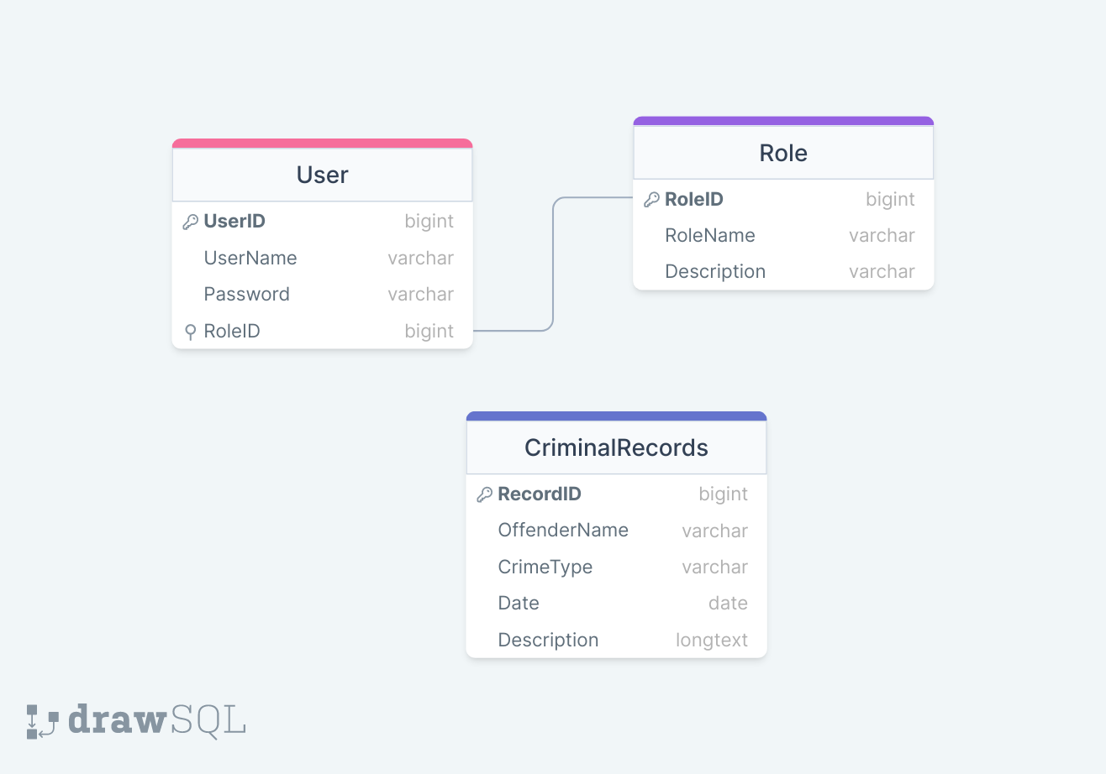

**User Interfaces**

**- Admin**

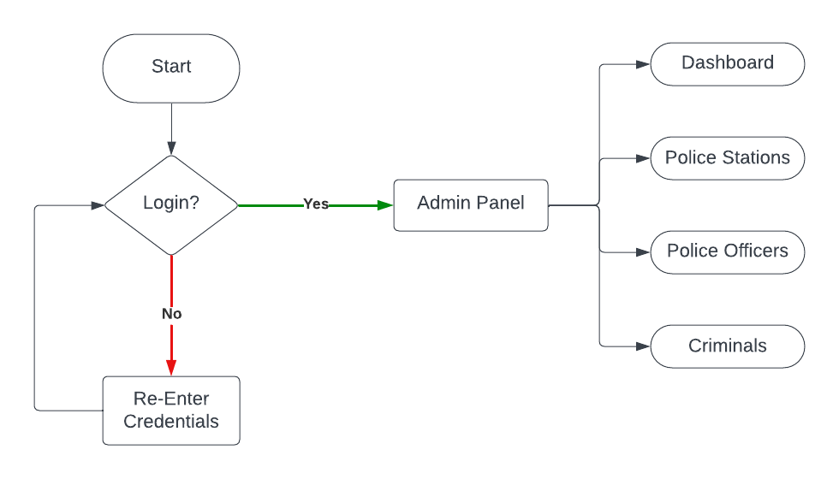

**- Police**

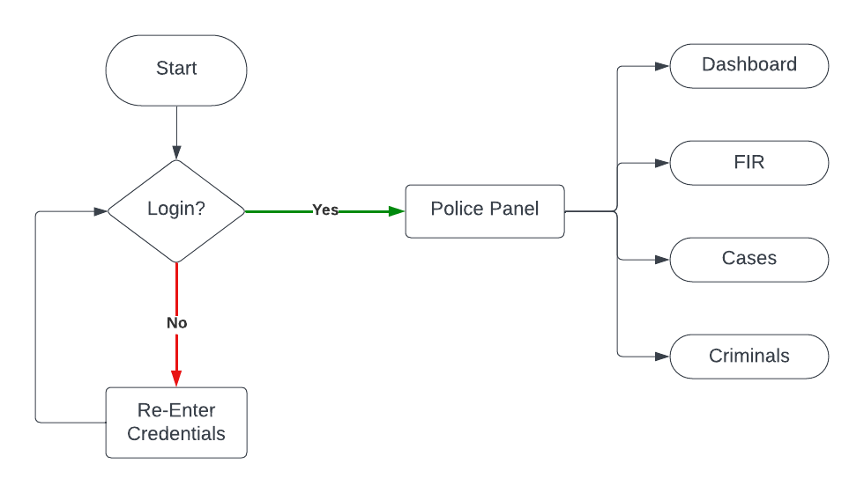

**- User**

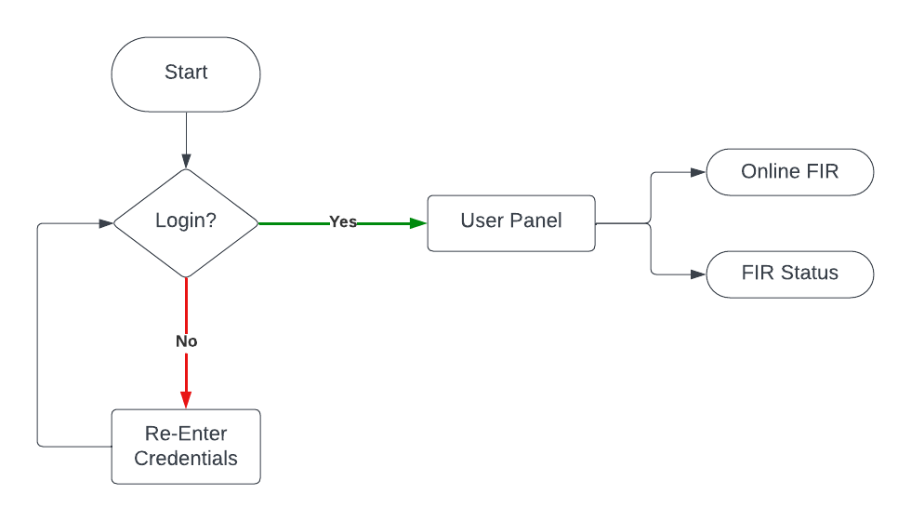

**User Roles and Permissions**

|  |  |  |
| --- | --- | --- |
| **UserID (Foreign Key)** | **RoleID (Foreign Key)** | **Permission** |
| **1** | **1** | **ADD_POLICE** |
| **1** | **1** | **UPDATE_POLICE** |
| **1** | **1** | **VIEW_ALL_RECORDS** |
| **2** | **2** | **VIEW_CRIMINALS** |
| **2** | **2** | **VIEW_CASE_DETAILS** |
| **2** | **2** | **ADD_CASE** |
| **3** | **3** | **ADD_NEW_FIR** |
| **3** | **3** | **VIEW_FIR_STATUS** |
| **4** | **1** | **VIEW_ALL_RECORDS** |
| **4** | **2** | **VIEW_CRIMINALS** |

**RoleID:**

**1 – ADMIN**

**2 – POLICE**

**3 – USERS**

**System Functionality**

**User Registration and Authentication**

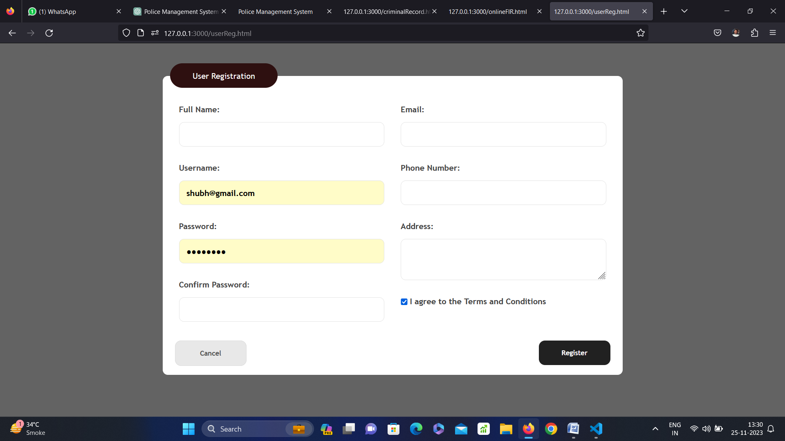

**Online FIR Filing**

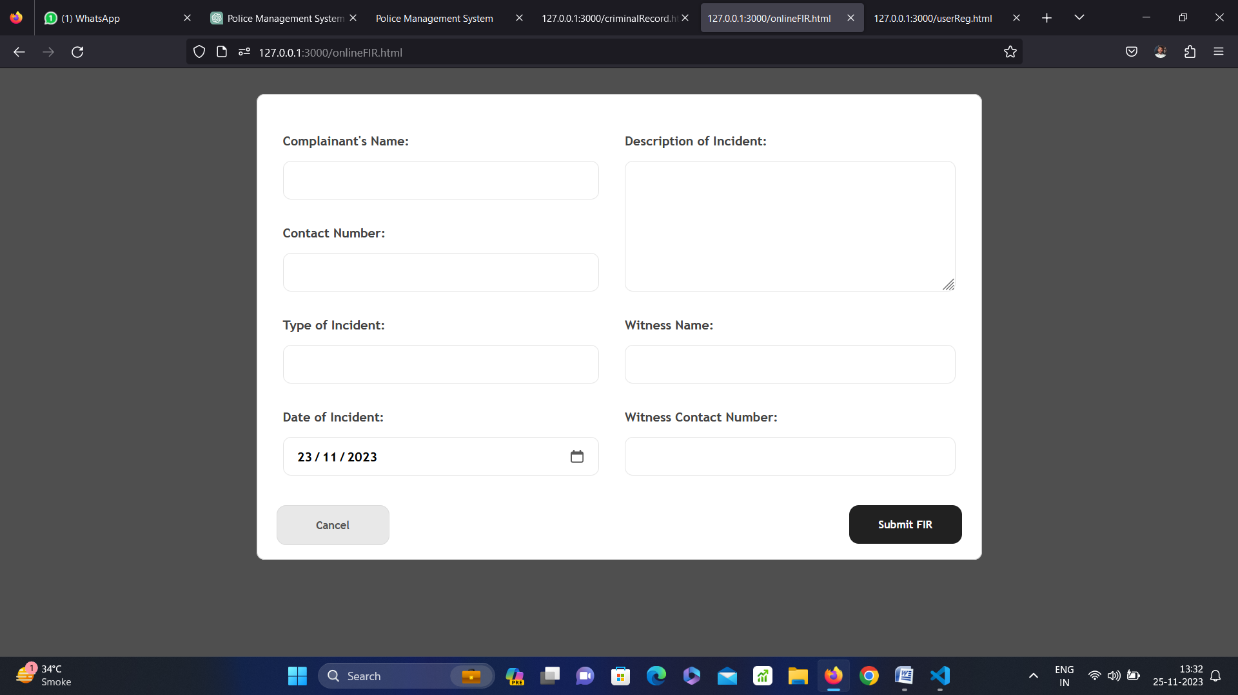

**Viewing and Tracking FIRs**

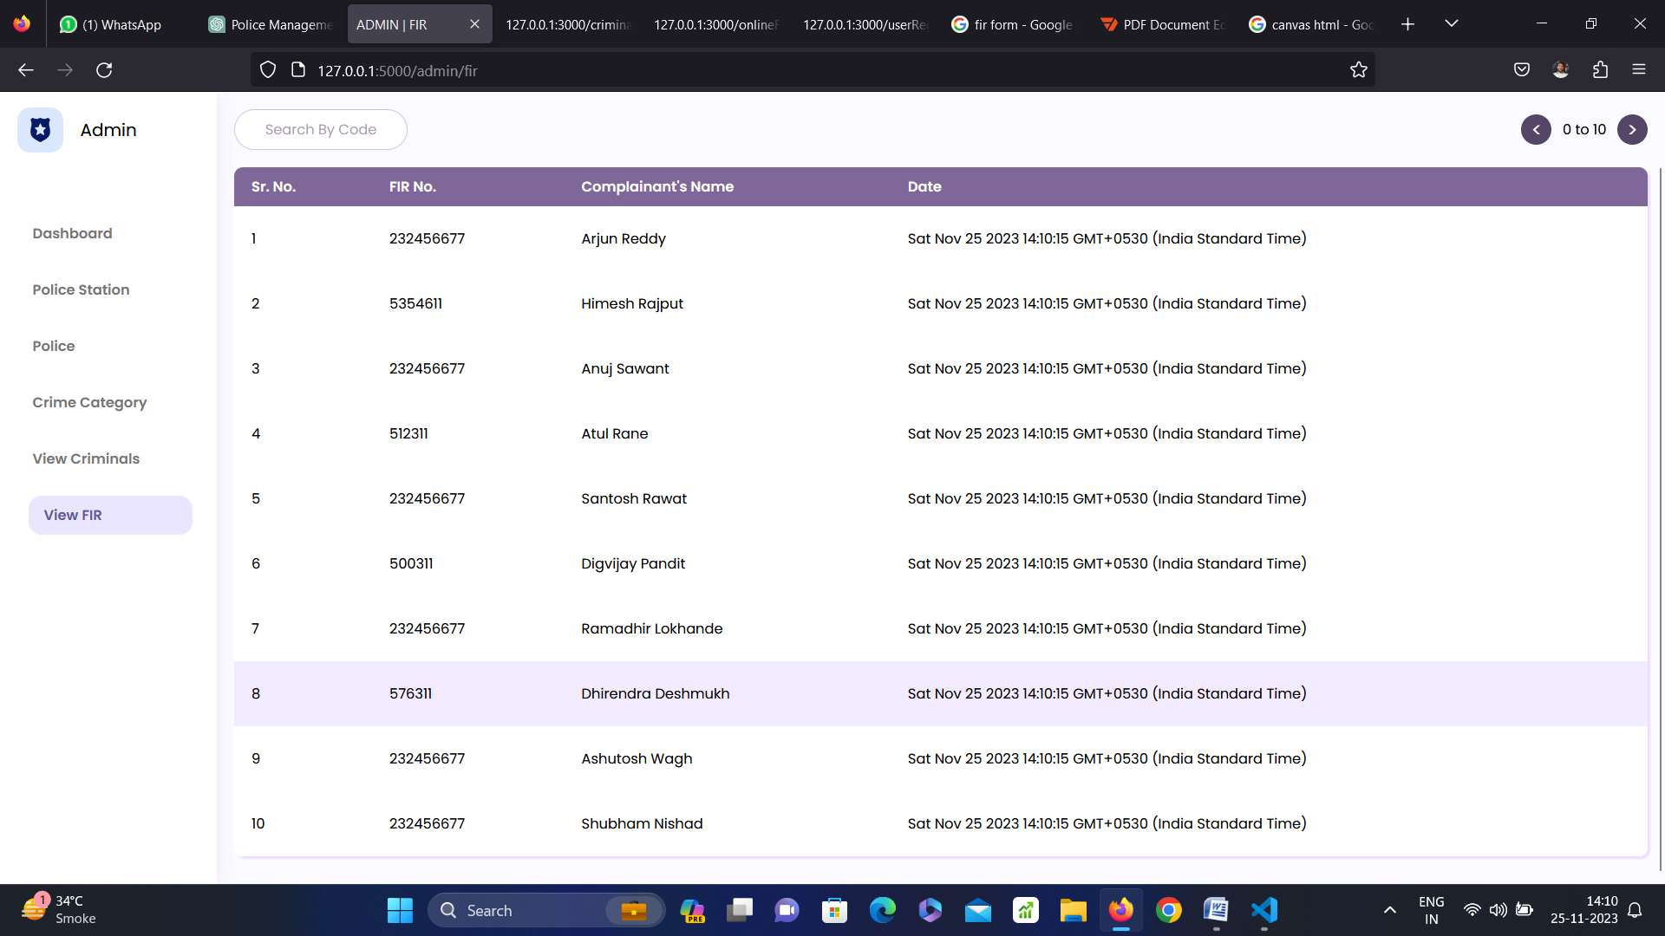

**Criminal Record Management**

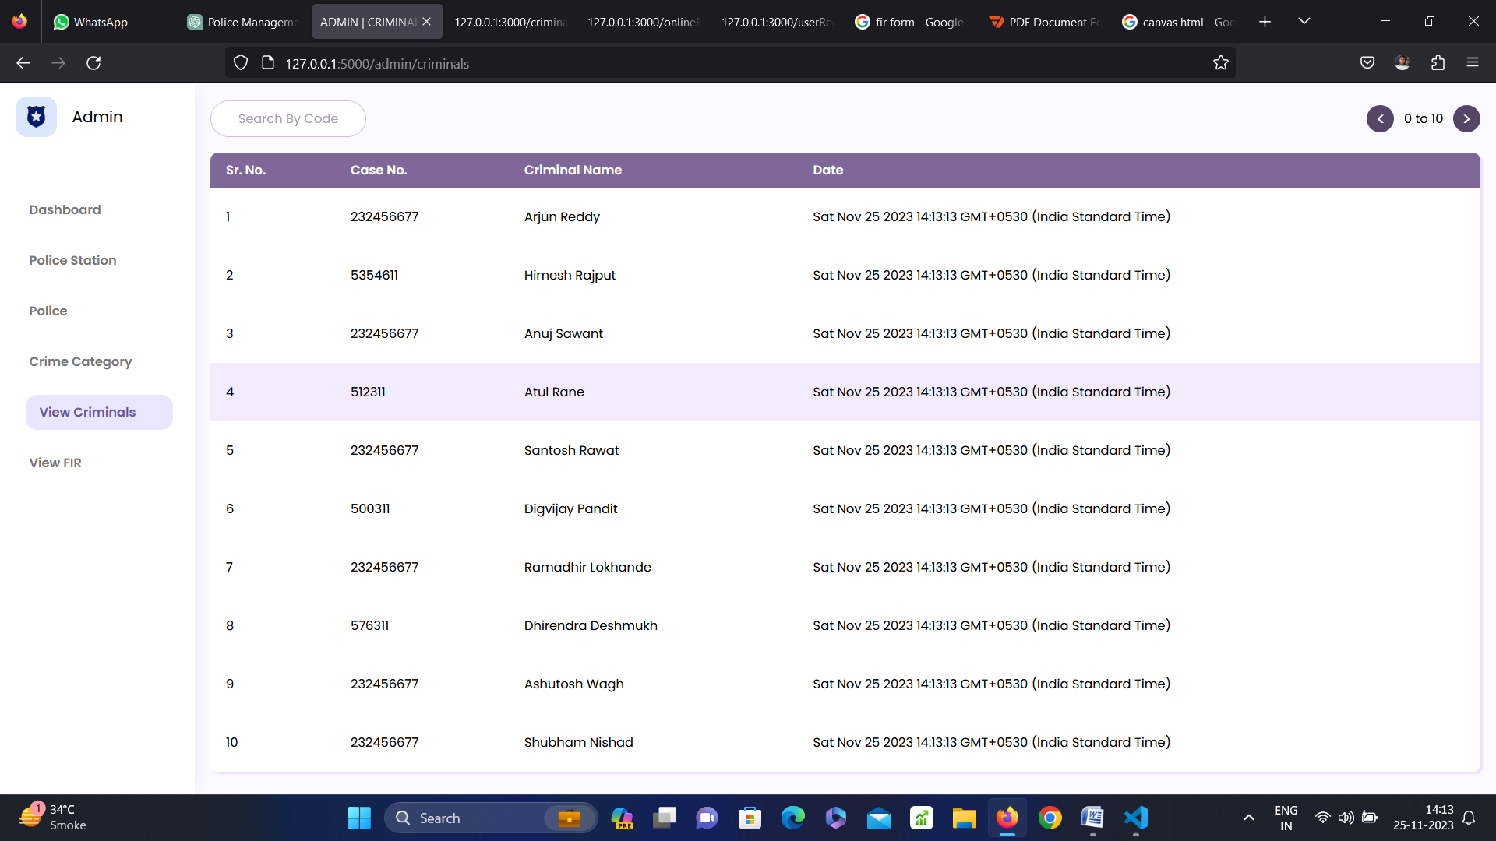

**Admin Panel**

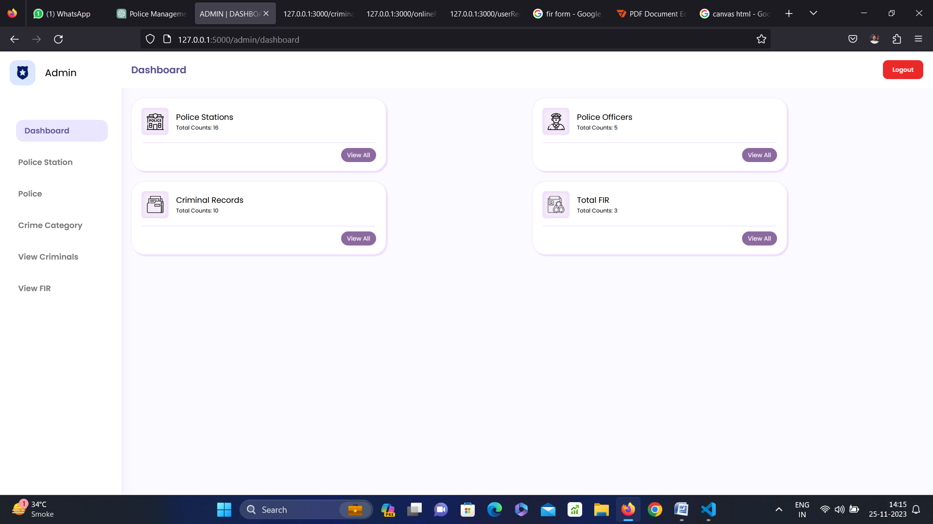**Implementation Details**

**App.py**

from flask import Flask,jsonify,render_template,request,redirect,session,url_for,sessions,Response

app = Flask(__name__)

app.secret_key = 'C@NYoUh@cktHiS'

@app.route('/')

def index():

  return render_template('index.html')

@app.route('/admin',methods=['GET','POST'])

def admin():

  if request.method == "POST":

    session['user'] = 'admin'

    return redirect('admin/dashboard')

  if request.method == 'GET':

    if session.get('user') :

      if session['user'] == 'admin':

        return redirect('admin/dashboard')

      else:

        page = session['user']

        return redirect(page+'/dashboard')

    return render_template('admin/index.html')

@app.route('/police',methods=['GET','POST'])

def police():

  if request.method == "POST":

    session['user'] = 'police'

    return redirect('police/dashboard')

  if request.method == 'GET':

    if session.get('user') :

      if session['user'] == 'police':

        return redirect('police/dashboard')

      else:

        page = session['user']

        return redirect(page+'/dashboard')

    return render_template('police/index.html')

@app.route('/user')

def user():

  return render_template('user/index.html')

@app.route('/admin/logout')

def adminLogout():

   session.pop('user',None)

   return redirect(url_for('index'))

@app.route('/police/logout')

def policeLogout():

   session.pop('user',None)

   return redirect(url_for('index'))

@app.route('/police/<page>')

def police_dashboard(page):

  return render_template('police/dashboard.html',officer_name="Shubham Nishad",url=page,ps_counts=len(p_stations),c_counts=10,fir_counts=3,po_counts=5)

@app.route('/admin/<page>')

def admin_dashboard(page):

  return render_template('admin/dashboard.html',url=page,ps_counts=len(p_stations),c_counts=10,fir_counts=3,po_counts=5)

@app.route('/api/police_stations',methods=['GET'])

def api_police_stations():

  return jsonify(p_stations)

@app.route('/api/police',methods=['GET'])

def api_police():

  return jsonify(p_officers)

@app.route('/api/categories')

def api_categories():

  return jsonify(crime_categories)

if __name__ == '__main__':

  app.run()

**index.html**

<!DOCTYPE html>

<html lang="en">

<head>

  <meta charset="UTF-8">

  <meta name="viewport" content="width=device-width, initial-scale=1.0">

  <title>Police Management System</title>

  <link rel="stylesheet" href="{{url_for('static',filename='css/global.css')}}">

  <link rel="stylesheet" href="{{url_for('static',filename='css/index.css')}}">

  <link rel="stylesheet" href="https://cdnjs.cloudflare.com/ajax/libs/font-awesome/6.4.2/css/all.min.css"

    integrity="sha512-z3gLpd7yknf1YoNbCzqRKc4qyor8gaKU1qmn+CShxbuBusANI9QpRohGBreCFkKxLhei6S9CQXFEbbKuqLg0DA=="

    crossorigin="anonymous" referrerpolicy="no-referrer" />

</head>

<body>

  <script>

    function rr() {

      window.location.assign("#main_section");

    }

  </script>

  <nav class="main_nav">

    <img src="{{url_for('static',filename='assets/badge.png')}}" width="46px" height="46px" alt="logo">

    <div>

      <p style="font-weight: 500; font-size: small; text-align: center; color: black;"><span style="font-weight: 600; font-size: medium;text-align: center; color: rgb(249, 60, 60);">Urgent Helpline:</span><br>+91-675 675 7546</p>

    </div>

  </nav>

  <header class="main_header">

    <div class="banner">

      <div class="glass-banner">

        <p>

          "Streamline Your Law Enforcement Operations."

        </p>

        <div class="cta1">

          <button type="button" onclick="rr()">

            Get Started

          </button>

        </div>

      </div>

  </header>

  <section class="main_section" id="main_section">

    <section>

      <img src="./../static/assets/icons8-admin-panel-66.png" alt="admin_panel">

      <div class="details">

        <p class="title">

          Admin Panel for Total Control.

        </p>

        <p class="desc">

          Effortlessly manage your entire law enforcement system with our comprehensive admin panel. Access detailed

          insights, control user access, and oversee the entire workflow.

        </p>

        <div>

          <a href="{{url_for('admin')}}" class="cta">Explore Admin Features.</a>

        </div>

      </div>

    </section>

    <section>

      <img src="./../static//assets/icons8-records-64.png" alt="police_panel">

      <div class="details">

        <p class="title">

          Empower Your Police Force.

        </p>

        <p class="desc">

          Equip your officers with powerful tools through the Police Panel. Streamline dispatch, access real-time data,

          and ensure efficient communication and coordination in the field.

        </p>

        <div>

          <a href="{{url_for('police')}}" class="cta">Discover Police Features.</a>

        </div>

      </div>

    </section>

    <section>

      <img src="./../static/assets/icons8-complaint-64.png" alt="user_panel">

      <div class="details">

        <p class="title">

          User-Friendly and Secure.

        </p>

        <p class="desc">

          Our User Panel offers a safe and user-friendly experience for citizens and stakeholders. Easily report

          incidents, access resources, and stay informed with our intuitive interface.

        </p>

        <div>

          <a href="{{url_for('user')}}" class="cta">Explore User Features.</a>

        </div>

      </div>

    </section>

  </section>

  <footer>

    <div class="contact_details">

      <div class="contact">

        <p><span style="font-weight: 600">Email: </span> manish@gmail.com</p>

        <p><span style="font-weight: 600">Mobile: </span> +91-223 323 4322</p>

        <div class="social_links">

          <a href="#"><i class="fa-brands fa-square-facebook"></i></a>

          <a href="#"><i class="fa-brands fa-youtube"></i></a>

          <a href="#"><i class="fa-brands fa-square-x-twitter"></i></a>

        </div>

      </div>

      <div class="address">

        <p>

          <span style="font-weight: 600">Street Address</span>: 123 Main Street <br>

          <span style="font-weight: 600">City</span>: Navi Mumbai <br>

          <span style="font-weight: 600">State</span>: Maharashtra <br>

          <span style="font-weight: 600">ZIP Code</span>: 400708 <br>

          <span style="font-weight: 600">Country</span>: India

        </p>

      </div>

    </div>

    <div class="dev_info">

      <p>Copyright © 2023 Manish Pal. All Rights Reserved.</p>

    </div>

  </footer>

</body>

</html>

**admin/dashboard.html**

<!DOCTYPE html>

<html lang="en">

<head>

  <meta charset="UTF-8">

  <meta name="viewport" content="width=device-width, initial-scale=1.0">

  <title>ADMIN | {{url.replace('_',' ').upper()}}</title>

  <link rel="stylesheet" href="{{url_for('static',filename='css/global.css')}}">

  <link rel="stylesheet" href="{{url_for('static',filename='css/admin.css')}}">

</head>

<body>

  <script src="https://cdnjs.cloudflare.com/ajax/libs/jquery/3.7.1/jquery.js"

  integrity="sha512-+k1pnlgt4F1H8L7t3z95o3/KO+o78INEcXTbnoJQ/F2VqDVhWoaiVml/OEHv9HsVgxUaVW+IbiZPUJQfF/YxZw=="

  crossorigin="anonymous" referrerpolicy="no-referrer"></script>

  <div class="wrapper">

    <nav class="sidebar">

      <div class="nav_header">

        <img onclick="red()" src="{{url_for('static',filename='assets/badge.png')}}" alt="logo" width="42px" height="42px">

        <p>Admin</p>

      </div>

      <a {% if url=='dashboard' %} class="active" {% endif %} href="dashboard">

        <p><span>Dashboard</span></p>

      </a>

      <a {% if url=='police_station' %} class="active" {% endif %} href="police_station">

        <p><span>Police Station</span></p>

      </a>

      <a {% if url=='police' %} class="active" {% endif %} href="police">

        <p><span>Police</span></p>

      </a>

      <a {% if url=='crime_category' %} class="active" {% endif %} href="crime_category">

        <p><span>Crime Category</span></p>

      </a>

      <a {% if url=='criminals' %} class="active" {% endif %} href="criminals">

        <p><span>View Criminals</span></p>

      </a>

      <a {% if url=='fir' %} class="active" {% endif %} href="fir">

        <p><span>View FIR</span></p>

      </a>

      <script>

        function red() {

          window.location.href = "/";

        }

      </script>

    </nav>

    {% if url=='dashboard' %}

    <main>

      <header>

        <p>Dashboard</p> <a href="logout">Logout</a>

      </header>

      <div class="content_wrapper">

        <div class="card">

          <div>

            <div class="sub_card">

              <img src="{{url_for('static',filename='assets/police-station.png')}}" alt="cop" width="28px" height="28px">

            </div>

            <div>

              <p>Police Stations</p>

              <p>Total Counts: {{ps_counts}}</p>

            </div>

          </div>

          <div class="line">

            <a href="police_station">View All</a>

          </div>

        </div>

        <div class="card">

          <div>

            <div class="sub_card">

              <img src="{{url_for('static',filename='assets/cop.png')}}" alt="cop" width="28px" height="28px">

            </div>

            <div>

              <p>Police Officers</p>

              <p>Total Counts: {{po_counts}}</p>

            </div>

          </div>

          <div class="line">

            <a href="police">View All</a>

          </div>

        </div>

        <div class="card">

          <div>

            <div class="sub_card">

              <img src="{{url_for('static',filename='assets/folder.png')}}" alt="cop" width="28px" height="28px">

            </div>

            <div>

              <p>Criminal Records</p>

              <p>Total Counts: {{c_counts}}</p>

            </div>

          </div>

          <div class="line">

            <a href="criminals">View All</a>

          </div>

        </div>

        <div class="card">

          <div>

            <div class="sub_card">

              <img src="{{url_for('static',filename='assets/criminal-database.png')}}" alt="cop" width="28px"

                height="28px">

            </div>

            <div>

              <p>Total FIR</p>

              <p>Total Counts: {{fir_counts}}</p>

            </div>

          </div>

          <div class="line">

            <a href="fir">View All</a>

          </div>

        </div>

      </div>

    </main>

    {% elif url=='police_station' %}

    <main>

      <header>

        <p>Police Stations</p> <a href="logout">Logout</a>

      </header>

      {% extends 'admin/police_station.html' %}

    </main>

    {% elif url=='police' %}

    <main>

      <header>

        <p>Police</p> <a href="logout" >Logout</a>

      </header>

      {% extends 'admin/police.html' %}

    </main>

    {% elif url=='crime_category' %}

    <main>

      <header>

        <p>Crime Categories</p> <a href="logout" >Logout</a>

      </header>

      {% extends 'admin/crime_category.html' %}

    </main>

    {% elif url=='criminals' %}

    <main>

      <header>

        <p>Criminals</p> <a href="logout">Logout</a>

      </header>

      {% extends 'admin/view_criminals.html' %}

    </main>

    {% elif url=='fir' %}

    <main>

      <header>

        <p>FIR</p> <a href="logout">Logout</a>

      </header>

      {% extends 'admin/fir.html' %}

    </main>

    {% else %}

    <main>

      <header>NOT FOUND</header>

    </main>

    {% endif %}

  </div>

</body>

</html>

**admin/ crime_category.html**

<div class="_wrapper">

  <div class="table_nav">

    <input type="text" class="_code" id="ct_code" name="ct_code" placeholder="Search By Code">

    <div class="t_n_btns">

      <button id="_prevBtn" type="button"><

        </button>

          <p><span id="_prev">0</span> to <span id="_next">10</span></p>

          <button id="_nextBtn" type="button">></button>

          <button onclick="handleNew()"><span>+</span>Add Category</button>

    </div>

  </div>

  <table>

    <thead>

      <tr>

        <th>

          Sr. No.

        </th>

        <th>

          Category Code

        </th>

        <th>

          Category Name

        </th>

      </tr>

    </thead>

    <tbody id="data_">

    </tbody>

    </tr>

  </table>

  <div class="update_box">

    <div class="ups_wrapper">

      <form action="/api/category/update" method="post">

        <div>

          <label for="ct_Code">Category Code</label><br>

          <input type="text" name="ct_Code" id="ct_Code" required>

        </div>

        <div>

          <label for="ct_name">Category Name</label><br>

          <input type="text" name="ct_name" id="ct_name" required>

        </div>

        <div class="_btns">

          <button type="submit">Update</button>

          <button type="button" onclick="handleClose()">Cancel</button>

        </div>

      </form>

    </div>

  </div>

  <div class="add_box">

    <div class="ups_wrapper">

      <form action="/api/category/add" method="post">

        <div>

          <label for="ct_Code">Category Code</label><br>

          <input type="text" name="ct_Code" id="ct_Code" required>

        </div>

        <div>

          <label for="ct_name">Category Name</label><br>

          <input type="text" name="ct_name" id="ct_name" required>

        </div>

        <!-- <div>

          <script src="https://unpkg.com/@lottiefiles/lottie-player@latest/dist/lottie-player.js"></script><lottie-player src="https://lottie.host/ecfb6bfc-4ad0-4fcb-9f5e-703991a4b8a2/PQSBKJAiUU.json" background="#FFFFFF" speed="1" style="width: 300px; height: 300px" loop autoplay direction="1" mode="normal"></lottie-player>

          <script src="https://unpkg.com/@dotlottie/player-component@latest/dist/dotlottie-player.mjs" type="module"></script>

    <dotlottie-player src="https://lottie.host/e37925e0-02fa-417c-84d3-451059f4d70f/4O044aaeXG.json" background="transparent" speed="1" style="width: 300px; height: 300px;" loop autoplay></dotlottie-player>

    <script src="https://unpkg.com/@dotlottie/player-component@latest/dist/dotlottie-player.mjs" type="module"></script>

    <dotlottie-player src="https://lottie.host/ef8668ae-1749-4a27-bf39-308c49ca8330/bpMYnk1loM.json" background="transparent" speed="1" style="width: 300px; height: 300px;" loop autoplay></dotlottie-player>

        </div> -->

        <div class="_btns">

          <button type="submit">Add</button>

          <button type="button" onclick="handleClose()">Cancel</button>

        </div>

      </form>

    </div>

  </div>

  <script>

    $(document).ready(function () {

      let g_data = [];

      $.get('/api/categories', (data, textStatus, jqXHR) => {

        g_data = data;

        renderData(data, 0, 10);

      }).fail(function () {

        document.getElementsByTagName('main').item(0).innerHTML = "Something went wrong...";

      });;

      $('#of_code').on('input', function (ele) {

        const f_data = g_data.filter((data) => {

          return data.id.includes(ele.target.value);

        });

        renderData(f_data, 0, 10);

      })

      $("#_prevBtn").on('click', function () {

        if (parseInt($("#_prev").text()) > 0) {

          document.getElementById("_prev").innerText = `${parseInt($("#_prev").text()) - 10}`;

          document.getElementById("_next").innerText = `${parseInt($("#_next").text()) - 10}`;

          let prev = parseInt($("#_prev").text());

          let next = parseInt($("#_next").text());

          renderData(g_data, prev, next);

        }

      })

      $("#_nextBtn").on('click', function () {

        if (parseInt($("#_next").text()) < g_data.length) {

          document.getElementById("_prev").innerText = `${parseInt($("#_prev").text()) + 10}`;

          document.getElementById("_next").innerText = `${parseInt($("#_prev").text()) + 10}`;

          let next = parseInt($("#_next").text());

          let prev = parseInt($("#_prev").text());

          renderData(g_data, prev, next);

        }

      });

      // $("tr").on('')

      function renderData(data, prev, next) {

        if (data.length > 10 && next < data.length) {

          const _data = data.slice(prev, next);

          let _trEle = "";

          for (let i = prev; i < next; i++) {

            _trEle += `<tr onclick='handleClick(this)'>

      <td>${i + 1}</td>

      <td>${data[i].code}</td>

      <td>${data[i].name}</td>

    </tr>`

          }

          document.getElementById('data_').innerHTML = _trEle;

        }

        else if (data.length == 0) {

          document.getElementsByTagName('tbody').item(0).innerHTML = "<h3>No data found</h3>";

        }

        else {

          let _trEle = "";

          for (let i = prev; i < data.length; i++) {

            _trEle += `<tr onclick='handleClick(this)'>

      <td>${i + 1}</td>

      <td>${data[i].code}</td>

      <td>${data[i].name}</td>

    </tr>`

          }

          document.getElementById('data_').innerHTML = _trEle;

        }

      }

    });

    function handleClick(ele) {

      const _code = ele.childNodes[3].innerText;

      const _name = ele.childNodes[5].innerText;

      document.querySelector("#ct_Code").value = _code;

      document.querySelector("#ct_name").value = _name;

      document.querySelector(".update_box").style.display = "flex";

    }

    function handleClose() {

      document.querySelector('.update_box').style.display = 'none';

      document.querySelector('.add_box').style.display = 'none';

    }

    function handleNew() {

      document.querySelector('.add_box').style.display = 'flex';

    }

  </script>

</div>

**admin/police_station.html**

<div class="_wrapper">

  <div class="table_nav">

    <input type="text" class="_code" id="st_code" name="st_code" placeholder="Search By Code">

    <div class="t_n_btns">

      <button id="_prevBtn" type="button"><

        </button>

          <p><span id="_prev">0</span> to <span id="_next">10</span></p>

          <button id="_nextBtn" type="button">></button>

          <button onclick="handleNew()"><span>+</span>Add Station</button>

    </div>

  </div>

  <table>

    <thead>

      <tr>

        <th>

          Sr. No.

        </th>

        <th>

          Station Code

        </th>

        <th>

          Station Name

        </th>

        <th>

          Address

        </th>

      </tr>

    </thead>

    <tbody id="data_">

    </tbody>

    </tr>

  </table>

  <div class="update_box">

    <div class="ups_wrapper">

      <form action="/api/police_station/update" method="post">

        <div>

          <label for="st_Code">Station Code</label><br>

          <input type="text" name="st_Code" id="st_Code" required>

        </div>

        <div>

          <label for="st_name">Station Name</label><br>

          <input type="text" name="st_name" id="st_name" required>

        </div>

        <div>

          <label for="st_address">Address</label><br>

          <input type="text" name="st_address" id="st_address" required>

        </div>

        <div class="_btns">

          <button type="submit">Update</button>

          <button type="button" onclick="handleClose()">Cancel</button>

        </div>

      </form>

    </div>

  </div>

  <div class="add_box">

    <div class="ups_wrapper">

      <form action="/api/police_station/add" method="post">

        <div>

          <label for="st_Code">Station Code</label><br>

          <input type="text" name="st_Code" id="st_Code" required>

        </div>

        <div>

          <label for="st_name">Station Name</label><br>

          <input type="text" name="st_name" id="st_name" required>

        </div>

        <div>

          <label for="st_address">Address</label><br>

          <input type="text" name="st_address" id="st_address" required>

        </div>

        <div class="_btns">

          <button type="submit">Update</button>

          <button type="button" onclick="handleClose()">Cancel</button>

        </div>

      </form>

    </div>

  </div>

  <script>

    $(document).ready(function () {

      let g_data = [];

      $.get('/api/police_stations', (data, textStatus, jqXHR) => {

        g_data = data;

        renderData(data, 0, 10);

      }).fail(function () {

        document.getElementsByTagName('main').item(0).innerHTML = "Something went wrong...";

      });;

      $('#st_code').on('input', function (ele) {

        const f_data = g_data.filter((data) => {

          return data.id.includes(ele.target.value);

        });

        renderData(f_data, 0, 10);

      })

      $("#_prevBtn").on('click', function () {

        if (parseInt($("#_prev").text()) > 0) {

          document.getElementById("_prev").innerText = `${parseInt($("#_prev").text()) - 10}`;

          document.getElementById("_next").innerText = `${parseInt($("#_next").text()) - 10}`;

          let prev = parseInt($("#_prev").text());

          let next = parseInt($("#_next").text());

          renderData(g_data, prev, next);

        }

      })

      $("#_nextBtn").on('click', function () {

        if (parseInt($("#_next").text()) < g_data.length) {

          document.getElementById("_prev").innerText = `${parseInt($("#_prev").text()) + 10}`;

          document.getElementById("_next").innerText = `${parseInt($("#_prev").text()) + 10}`;

          let next = parseInt($("#_next").text());

          let prev = parseInt($("#_prev").text());

          renderData(g_data, prev, next);

        }

      });

      // $("tr").on('')

      function renderData(data, prev, next) {

        if (data.length > 10 && next < data.length) {

          const _data = data.slice(prev, next);

          let _trEle = "";

          for (let i = prev; i < next; i++) {

            _trEle += `<tr onclick='handleClick(this)'>

      <td>${i + 1}</td>

      <td>${data[i].id}</td>

      <td>${data[i].name}</td>

      <td>${data[i].address}</td>

    </tr>`

          }

          document.getElementById('data_').innerHTML = _trEle;

        }

        else if (data.length == 0) {

          document.getElementsByTagName('tbody').item(0).innerHTML = "<h3>No data found</h3>";

        }

        else {

          let _trEle = "";

          for (let i = prev; i < data.length; i++) {

            _trEle += `<tr onclick='handleClick(this)'>

      <td>${i + 1}</td>

      <td>${data[i].id}</td>

      <td>${data[i].name}</td>

      <td>${data[i].address}</td>

    </tr>`

          }

          document.getElementById('data_').innerHTML = _trEle;

        }

      }

    });

    function handleClick(ele) {

      const _code = ele.childNodes[3].innerText;

      const _name = ele.childNodes[5].innerText;

      const _addr = ele.childNodes[7].innerText;

      document.querySelector("#st_Code").value = _code;

      document.querySelector("#st_name").value = _name;

      document.querySelector("#st_address").value = _addr;

      document.querySelector(".update_box").style.display = "flex";

    }

    function handleClose() {

      document.querySelector('.update_box').style.display = 'none';

      document.querySelector('.add_box').style.display = 'none';

    }

    function handleNew() {

      document.querySelector('.add_box').style.display = 'flex';

    }

  </script>

</div>

**Admin/police.html**

<div class="_wrapper">

  <div class="table_nav">

    <input type="text" class="_code" id="of_code" name="of_code" placeholder="Search By Code">

    <div class="t_n_btns">

      <button id="_prevBtn" type="button"><

        </button>

          <p><span id="_prev">0</span> to <span id="_next">10</span></p>

          <button id="_nextBtn" type="button">></button>

          <button onclick="handleNew()"><span>+</span>Add Officer</button>

    </div>

  </div>

  <table>

    <thead>

      <tr>

        <th>

          Sr. No.

        </th>

        <th>

          Officer Code

        </th>

        <th>

          Officer Name

        </th>

        <th>

          Station Code

        </th>

      </tr>

    </thead>

    <tbody id="data_">

    </tbody>

    </tr>

  </table>

  <div class="update_box">

    <div class="ups_wrapper">

      <form action="/api/police/update" method="post">

        <div>

          <label for="of_Code">Officer Code</label><br>

          <input type="text" name="of_Code" id="of_Code" required>

        </div>

        <div>

          <label for="of_name">Officer Name</label><br>

          <input type="text" name="of_name" id="of_name" required>

        </div>

        <div>

          <label for="st_code">Station Code</label><br>

          <input type="text" name="st_code" id="st_code" required>

        </div>

        <div class="_btns">

          <button type="submit">Update</button>

          <button type="button" onclick="handleClose()">Cancel</button>

        </div>

      </form>

    </div>

  </div>

  <div class="add_box">

    <div class="ups_wrapper">

      <form action="/api/police/add" method="post">

        <div>

          <label for="of_Code">Officer Code</label><br>

          <input type="text" name="of_Code" id="of_Code" required>

        </div>

        <div>

          <label for="of_name">Officer Name</label><br>

          <input type="text" name="of_name" id="of_name" required>

        </div>

        <div>

          <label for="st_code">Station Code</label><br>

          <input type="text" name="st_code" id="st_code" required>

        </div>

        <div class="_btns">

          <button type="submit">Add</button>

          <button type="button" onclick="handleClose()">Cancel</button>

        </div>

      </form>

    </div>

  </div>

  <script>

    $(document).ready(function () {

      let g_data = [];

      $.get('/api/police', (data, textStatus, jqXHR) => {

        g_data = data;

        renderData(data, 0, 10);

      }).fail(function () {

        document.getElementsByTagName('main').item(0).innerHTML = "Something went wrong...";

      });;

      $('#of_code').on('input', function (ele) {

        const f_data = g_data.filter((data) => {

          return data.id.includes(ele.target.value);

        });

        renderData(f_data, 0, 10);

      })

      $("#_prevBtn").on('click', function () {

        if (parseInt($("#_prev").text()) > 0) {

          document.getElementById("_prev").innerText = `${parseInt($("#_prev").text()) - 10}`;

          document.getElementById("_next").innerText = `${parseInt($("#_next").text()) - 10}`;

          let prev = parseInt($("#_prev").text());

          let next = parseInt($("#_next").text());

          renderData(g_data, prev, next);

        }

      })

      $("#_nextBtn").on('click', function () {

        if (parseInt($("#_next").text()) < g_data.length) {

          document.getElementById("_prev").innerText = `${parseInt($("#_prev").text()) + 10}`;

          document.getElementById("_next").innerText = `${parseInt($("#_prev").text()) + 10}`;

          let next = parseInt($("#_next").text());

          let prev = parseInt($("#_prev").text());

          renderData(g_data, prev, next);

        }

      });

      // $("tr").on('')

      function renderData(data, prev, next) {

        if (data.length > 10 && next < data.length) {

          const _data = data.slice(prev, next);

          let _trEle = "";

          for (let i = prev; i < next; i++) {

            _trEle += `<tr onclick='handleClick(this)'>

      <td>${i + 1}</td>

      <td>${data[i].id}</td>

      <td>${data[i].name}</td>

      <td>${data[i].st_code}</td>

    </tr>`

          }

          document.getElementById('data_').innerHTML = _trEle;

        }

        else if (data.length == 0) {

          document.getElementsByTagName('tbody').item(0).innerHTML = "<h3>No data found</h3>";

        }

        else {

          let _trEle = "";

          for (let i = prev; i < data.length; i++) {

            _trEle += `<tr onclick='handleClick(this)'>

      <td>${i + 1}</td>

      <td>${data[i].id}</td>

      <td>${data[i].name}</td>

      <td>${data[i].st_code}</td>

    </tr>`

          }

          document.getElementById('data_').innerHTML = _trEle;

        }

      }

    });

    function handleClick(ele) {

      const _code = ele.childNodes[3].innerText;

      const _name = ele.childNodes[5].innerText;

      const _scode = ele.childNodes[7].innerText;

      document.querySelector("#of_Code").value = _code;

      document.querySelector("#of_name").value = _name;

      document.querySelector("#st_code").value = _scode;

      document.querySelector(".update_box").style.display = "flex";

    }

    function handleClose() {

      document.querySelector('.update_box').style.display = 'none';

      document.querySelector('.add_box').style.display = 'none';

    }

    function handleNew() {

      document.querySelector('.add_box').style.display = 'flex';

    }

  </script>

</div>

**admin/view_criminals.html**

<div class="_wrapper">

  <div class="table_nav">

    <input type="text" class="_code" id="of_code" name="of_code" placeholder="Search By Code">

    <div class="t_n_btns">

      <button id="_prevBtn" type="button"><

        </button>

          <p><span id="_prev">0</span> to <span id="_next">10</span></p>

          <button id="_nextBtn" type="button">></button>

    </div>

  </div>

  <table>

    <thead>

      <tr>

        <th>

          Sr. No.

        </th>

        <th>

          Case No.

        </th>

        <th>

          Criminal Name

        </th>

        <th>

          Date

        </th>

      </tr>

    </thead>

    <tbody id="data_">

    </tbody>

    </tr>

  </table>

  </div>

  <script>

    $(document).ready(function () {

      let g_data = [];

      $.get('/api/police', (data, textStatus, jqXHR) => {

        g_data = data;

        renderData(data, 0, 10);

      }).fail(function () {

        document.getElementsByTagName('main').item(0).innerHTML = "Something went wrong...";

      });;

      $('#of_code').on('input', function (ele) {

        const f_data = g_data.filter((data) => {

          return data.id.includes(ele.target.value);

        });

        renderData(f_data, 0, 10);

      })

      $("#_prevBtn").on('click', function () {

        if (parseInt($("#_prev").text()) > 0) {

          document.getElementById("_prev").innerText = `${parseInt($("#_prev").text()) - 10}`;

          document.getElementById("_next").innerText = `${parseInt($("#_next").text()) - 10}`;

          let prev = parseInt($("#_prev").text());

          let next = parseInt($("#_next").text());

          renderData(g_data, prev, next);

        }

      })

      $("#_nextBtn").on('click', function () {

        if (parseInt($("#_next").text()) < g_data.length) {

          document.getElementById("_prev").innerText = `${parseInt($("#_prev").text()) + 10}`;

          document.getElementById("_next").innerText = `${parseInt($("#_prev").text()) + 10}`;

          let next = parseInt($("#_next").text());

          let prev = parseInt($("#_prev").text());

          renderData(g_data, prev, next);

        }

      });

      // $("tr").on('')

      function renderData(data, prev, next) {

        if (data.length > 10 && next < data.length) {

          const _data = data.slice(prev, next);

          let _trEle = "";

          for (let i = prev; i < next; i++) {

            _trEle += `<tr onclick='handleClick(this)'>

      <td>${i + 1}</td>

      <td>${data[i].id}</td>

      <td>${data[i].name}</td>

      <td>${Date().toString()}</td>

    </tr>`

          }

          document.getElementById('data_').innerHTML = _trEle;

        }

        else if (data.length == 0) {

          document.getElementsByTagName('tbody').item(0).innerHTML = "<h3>No data found</h3>";

        }

        else {

          let _trEle = "";

          for (let i = prev; i < data.length; i++) {

            _trEle += `<tr onclick='handleClick(this)'>

      <td>${i + 1}</td>

      <td>${data[i].id}</td>

      <td>${data[i].name}</td>

      <td>${data[i].st_code}</td>

    </tr>`

          }

          document.getElementById('data_').innerHTML = _trEle;

        }

      }

    });

  </script>

</div>

**admin.css**

.wrapper {

  position: fixed;

  display: grid;

  grid-template-columns: 200px auto;

  top: 0;

  left: 0;

  right: 0;

  bottom: 0;

}

.admin_login_wrapper {

  position: absolute;

  display: flex;

  justify-content: center;

  align-items: center;

  top: 0;

  bottom: 0;

  right: 0;

  left: 0;

  background-color: rgb(237, 241, 251);

}

.nav_header {

  width: 100%;

  height: 60px;

  display: flex;

  gap: 1rem;

  /* justify-content: center; */

  align-items: center;

  margin-bottom: 2rem;

  margin-top: 5px;

}

.nav_header img {

  padding: 10px;

  background-color: rgb(219, 230, 255);

  border-radius: 12px;

}

.nav_header img:hover {

  cursor: pointer;

}

.admin_login_form {

  display: flex;

  flex-direction: column;

  gap: 1rem;

  padding: 2rem 2.5rem;

  background-color: white;

  border-radius: 1rem;

}

.admin_login_form label {

  display: block;

  font-weight: 600;

  margin-bottom: 12px;

  margin-left: 2px;

}

.admin_login_form input {

  font-weight: 400;

  font-size: small;

  padding: 10px 16px;

  border: 0.5px solid rgba(128, 128, 128, 0.295);

  border-radius: 12px;

  outline: none;

}

.admin_login_form input:focus {

  border: 1px solid rgb(183, 145, 224);

}

.admin_login_form input[type="submit"]:hover {

  cursor: pointer;

}

.sidebar {

  z-index: 10;

  position: relative;

  display: flex;

  flex-direction: column;

  gap: 1rem;

  /* width: 200px; */

  top: 0;

  bottom: 0;

  background-color: rgb(255, 255, 255);

  padding: 0px 16px;

  box-shadow: 0px 1px 16px rgb(236, 230, 252);

}

.active{

  transform: translateX(10px);

  background-color: rgb(235, 230, 255);

}

.active span {

  color: rgb(100, 89, 156);

  font-weight: 600;

}

main {

  position: relative;

  width: 100%;

  height: 100%;

  background-color: rgb(251, 250, 255);

  overflow-y: scroll;

}

main header {

  position: relative;

  z-index: 11;

  display: flex;

  justify-content: space-between;

  font-weight: 600;

  color: rgb(90, 80, 140);

  align-items: center;

  background-color: rgb(255, 255, 255);

  width: 100%;

  min-width: 470px;

  height: 60px;

  padding:0 1rem;

}

main header a {

  text-decoration: none;

  padding: 8px 16px;

  background-color: rgb(235, 41, 41);

  color: white;

  border-radius: 8px;

  border: none;

  font-size: x-small;

}

main header button:hover {

  cursor: pointer;

}

.sidebar a {

  position: relative;

  text-decoration: none;

  border-radius: 12px;

  color: rgba(94, 93, 93, 0.848);

  padding: 8px 14px;

  font-size: small;

  font-weight: 600;

  width: 90%;

  transition: transform 260ms ease-in-out;

}

.sidebar a:hover {

  color: rgb(100, 89, 156);

  background-color: rgb(235, 230, 255);

  transform: translateX(10px);

}

.content_wrapper {

  display: grid;

  grid-template-columns: 1fr 1fr;

  grid-template-rows: 1fr 1fr;

  gap: 1rem;

  width: 100%;

  padding: 1rem;

}

.card {

  padding: 1rem 1rem 0.5rem 1rem;

  width: 95%;

  min-width: 210px;

  max-width: 420px;

  border-radius: 22px;

  background-color: rgb(255, 255, 255);

  box-shadow: 2px 2px 2px rgba(198, 134, 255, 0.249);

  border: 0.5px solid rgba(144, 0, 255, 0.107);

}

.card div {

  display: flex;

  align-items: center;

  gap: 12px;

  margin-bottom: 6px;

}

.card div div:nth-child(2) {

  display: block;

  padding: 0;

}

.card div div:nth-child(2) p:nth-child(2) {

  font-size: xx-small;

  font-weight: 400;

}

.line {

  border-top: 2px solid rgba(183, 145, 224, 0.172);

  border-radius: 2px;

}

.sub_card {

  display: inline-flex;

  justify-content: center;

  align-items: center;

  width: 45px;

  height: 45px;

  border-radius: 6px;

  border: 2px solid rgb(243, 224, 255);

  background-color: rgb(244, 236, 248);

  box-shadow: 0px 0px 7px rgba(218, 132, 255, 0.249) inset;

}

.card p {

  font-size: small;

}

.card div:nth-child(2) {

  margin-bottom: none;

  justify-content: end;

  padding-top: 8px;

}

.card div:nth-child(2) a {

  padding: 4px 10px;

  background-color: rgb(140, 106, 160);

  color: white;

  text-decoration: none;

  font-weight: 400;

  font-size: x-small;

  border-radius: 12px;

}

._wrapper {

  position: relative;

  padding: 1rem;

  width: 100% ;

  height: 100%;

}

/* .police_station_wrapper table {

  text-align: left;

  font-size: small;

  border-collapse: collapse;

  padding: 1rem;

}

.police_station_wrapper table thead{

  background-color: rgb(140, 106, 160);

  color: white;

} */

._wrapper table {

  border-radius: 8px;

  background-color: white;

  box-shadow: 2px 2px 2px rgba(198, 134, 255, 0.249);

  text-align: left;

  font-size: small;

  border-collapse: collapse;

  width: 100%;

  min-width: 430px;

  height: 170px ;

  overflow: hidden;

}

.table_nav {

  display: flex;

  align-items: center;

  width: 100%;

  gap: 1rem;

  padding: 1rem 0;

  margin-top: -1rem;

  justify-content: space-between;

}

.table_nav>button {

  display: inline-flex;

  padding: 4px 10px;

  border-radius: 4px;

  gap: 8px;

  border: 0.5px solid rgb(183, 145, 224);

  background-color: rgb(241, 229, 255);

  color: rgb(134, 87, 184);

}

._code {

  padding:8px 12px;

  outline: none;

  border: none;

  border-radius: 1.5rem;

  text-align: center;

  width: 160px;

  border: 1px solid rgba(183, 145, 224, 0.596);

  font-size: small;

  color: rgb(97, 74, 111);

}

.t_n_btns {

  display: flex;

  gap: 10px;

  align-items: center;

  justify-content: flex-end;

  width: max-content;

}

.t_n_btns p {

  font-size: small;

  font-weight: 400;

}

.t_n_btns button:nth-child(1), .t_n_btns button:nth-child(3) {

  font-size: 18px;

  color: white;

  width: 28px;

  height: 28px;

  text-align: center;

  background-color: rgb(85, 70, 103);

  border-radius: 50%;

  border: none;

}

.t_n_btns button:nth-child(4) {

  display: inline-flex;

  padding: 6px 10px;

  border-radius: 1rem;

  gap: 8px;

  border: 0.5px solid rgb(183, 145, 224);

  background-color: rgb(241, 229, 255);

  color: rgb(134, 87, 184);

}

.t_n_btns button:hover {

  cursor: pointer;

}

._wrapper table tbody tr td {

  padding: 0.5rem 1rem;

  font-size: small;

}

._wrapper table tbody tr:hover {

  background-color: rgb(243, 235, 255);

  cursor: pointer;

}

._wrapper table thead tr th{

  background-color: rgb(127, 104, 153);

  padding: 0.5rem 1rem;

  color: white;

  font-weight: 600;

}

._wrapper table thead tr{

  max-height: 20px;

}

._wrapper table tbody tr{

  height: 60px;

}

.update_box {

  display: none;

  position: fixed;

  z-index: 11;

  justify-content: center;

  align-items: center;

  top: 0;

  bottom: 0;

  left: 0;

  right: 0;

  background-color: rgba(0, 0, 0, 0.271);

}

.add_box {

  display: none;

  position: fixed;

  z-index: 11;

  justify-content: center;

  align-items: center;

  top: 0;

  bottom: 0;

  left: 0;

  right: 0;

  background-color: rgba(0, 0, 0, 0.271);

}

.ups_wrapper form {

  display: grid;

  grid-template-columns: 1fr 1fr;

  grid-template-rows: 1fr 1fr 1fr;

  gap: 1rem;

  height: 80%;

  width: max-content;

  background-color: white;

  border-radius: 8px;

  padding: 2rem;

}

._btns {

  grid-row: 3;

  grid-column: 1 / 3;

  display: flex;

  justify-self: flex-end;

  align-items: center;

  gap: 1rem;

}

.ups_wrapper form label {

  font-size: small;

}

.ups_wrapper form input {

  padding: 8px 14px;

  border-radius: 8px;

  width: max-content;

  font-size: small;

  outline: none;

  border: 2px solid rgb(231, 231, 231);

}

.ups_wrapper form input:focus {

  border: 2px solid rgb(216, 216, 216);

}

._btns button {

  float: right;

  padding: 10px 20px;

  border: none;

  border-radius: 4px;

  font-weight: 600;

  font-size: 10px;

  cursor: pointer;

  box-shadow: 1px 1px 4px rgba(207, 207, 207, 0.498);

}

._btns button:nth-child(1) {

  background-color: rgb(255, 79, 79);

  color: rgb(255, 255, 255);

  margin-right: 0px;

}

._btns button:nth-child(2) {

  background-color: rgb(116, 74, 168);

  color: white;

  border: none;

}

@media screen and (max-width: 650px) {

  .ups_wrapper form {

    display: flex;

    flex-direction: column;

  }

  ._btns {

    width: max-content;

    justify-content: flex-end;

  }

  .table_nav {

    width: max-content;

  }

}

**index.css**

a {

  text-decoration: none;

}

.main_nav{

  background-color: white;

  height: 70px;

  box-shadow: 2px 4px 4px rgb(28, 28, 28);

  border: 0.5px solid rgba(173, 216, 230, 0.553);

  display: flex;

  align-items: center;

  padding: 0px 20px;

  justify-content: space-between;

}

.main_nav img {

  padding: 10px;

  background-color: rgb(219, 230, 255);

  border-radius: 12px;

}

.banner {

  position: relative;

  width: 100%;

  height: 320px;

  background-color: rgb(238, 251, 255);

  background-image: url('./../assets/policeBG.JPG');

  background-repeat: no-repeat;

  background-size: 100% 100%;

  background-attachment: fixed;

}

.glass-banner {

  position: absolute;

  display: flex;

  flex-direction: column;

  justify-content: center;

  align-items: center;

  gap: 1rem;

  height: 100%;

  width: 100%;

  background:linear-gradient(to left,rgba(0, 0, 0, 0.942) , rgba(7, 6, 3, 0.83),rgba(0, 0, 0, 0.902));

}

.glass-banner p {

  text-align: center;

  color: white;

  font-size: 36px;

  font-weight: 800;

  font-family: "Poppins";

}

.cta1 {

  border: 2px solid white;

  padding: 6px 12px;

  width: 140px;

  border-radius: 12px;

}

.cta1:hover {

  background-color: rgba(194, 192, 254, 0.472);

}

.cta1 button {

  position: relative;

  left: -10px;

  border: none;

  background: none;

  width: 100%;

  height: 100%;

  color: white;

  font-weight: 400;

  font-size: small;

}

button:hover {

  cursor: pointer;

}

.cta1 button::after {

  top: 6px;

  right: -2px;

  position: absolute;

  content: "";

  width: 6px;

  height: 6px;

  border-bottom: 2px solid white;

  border-left: 2px solid white;

  transform: rotate(-45deg);

}

.main_section {

  padding: 20px;

  display: flex;

  flex-wrap: wrap;

  width: 100vw;

  height: fit-content;

  justify-content: center;

  gap: 1rem;

}

.main_section section {

  display: flex;

  align-items: center;

  border-radius: 12px;

  border: 0.5px solid rgba(177, 176, 176, 0.546);

  padding: 15px 20px;

}

.main_section section img {

  padding: 20px 20px 20px 0px;

  border-radius: 12px;

}

.title {

  font-weight: 600;

  font-size: medium;

  margin-bottom: 10px;

}

.desc {

  font-weight: 400;

  font-size: small;

  margin-bottom: 10px;

}

.cta {

  border: 0.5px solid rgb(117, 78, 152);

  padding: 4px 8px;

  font-size: x-small;

  font-weight: 400;

  border-radius: 12px;

  background-color: rgb(237, 241, 251);

}

.cta:hover {

  background-color: rgb(152, 181, 255);

  cursor: pointer;

}

.contact_details {

  display: grid;

  grid-template-columns: 1fr 1fr;

  padding: 1rem;

  background-color: rgb(237, 241, 251);

}

.contact p:nth-child(2){

  margin-bottom: 1rem;

}

.social_links {

  display: flex;

  gap: 1rem;

  align-items: center;

  margin-left: 40px;

}

.social_links i{

  color: rgb(250, 244, 255);

  font-size: 19px;

}

.social_links a i:hover{

  color: rgb(248, 241, 255);

  font-size: 19px;

}

.social_links a:nth-child(1) i{

  color: rgb(35, 90, 200);

  font-size: 20.5px;

}

.social_links a:nth-child(2) i{

  color: rgb(228, 39, 10);

  font-size: 23px;

}

.social_links a:nth-child(3) i{

  color: rgb(18, 18, 18);

  font-size: 20.5px;

}

.dev_info {

  background-color: rgb(62, 68, 81);

}

.dev_info p {

  text-align: center;

  font-size: x-small;

  color: white;

  padding: 8px 0px;

}

# Security Measures

Ensuring the security of the Criminal Record Management is paramount to safeguard sensitive information and maintain the integrity of the system. The following security measures have been implemented to mitigate potential risks and protect user data:

## User Authentication

### Encryption of Passwords

All user passwords are securely encrypted using industry-standard cryptographic hashing algorithms. This ensures that even in the event of a data breach, plain-text passwords remain inaccessible to unauthorized parties.

### Two-Factor Authentication (2FA)

For an additional layer of security, Two-Factor Authentication (2FA) has been implemented. This requires users to provide a secondary verification method, typically through a mobile device or email, along with their login credentials.

## Data Security

### Access Controls

Role-based access controls have been implemented to restrict user access based on their roles. This ensures that each user has the minimum necessary permissions to perform their specific tasks, reducing the risk of unauthorized access to sensitive information.

### Secure Communication Protocols

The Criminal Record Management uses HTTPS (Hypertext Transfer Protocol Secure) to encrypt data in transit between the client and the server. This safeguards against man-in-the-middle attacks and ensures the confidentiality and integrity of data during transmission.

## System Monitoring and Logging

### Logging Critical Events

The system logs critical events, such as login attempts, user activity, and system changes. These logs are regularly reviewed and monitored to detect any suspicious or unauthorized activities.

### Intrusion Detection System (IDS)

An Intrusion Detection System is in place to monitor the system for unusual patterns or behaviors that may indicate a potential security threat. Alerts are generated in real-time, allowing for prompt investigation and mitigation.

## Regular Security Audits and Assessments

### Penetration Testing

Regular penetration testing is conducted to identify and address potential vulnerabilities in the system. This proactive approach helps to strengthen security measures and address any emerging threats.

### Code Reviews

Routine code reviews are performed to ensure that the system's source code adheres to secure coding practices. This process helps identify and rectify any vulnerabilities in the early stages of development.

## Data Backup and Recovery

### Regular Data Backups

Periodic data backups are conducted to prevent data loss in the event of system failures, hardware malfunctions, or unforeseen incidents. These backups are stored securely and can be readily restored if needed.

### Disaster Recovery Plan

A comprehensive disaster recovery plan is in place to ensure a swift and effective response to any unforeseen incidents. This plan includes procedures for data recovery, system restoration, and communication with relevant stakeholders.

By implementing these security measures, the Criminal Record Management aims to create a robust and secure environment for managing criminal records, ensuring the confidentiality, integrity, and availability of data.

## Conclusion

### Achievements

The completion of the "Criminal Record Management" project marks a significant achievement in the pursuit of modernizing law enforcement practices. This project has successfully addressed key challenges in criminal record management, online FIR filing, and case tracking, contributing to the efficiency and transparency of law enforcement agencies.

#### Technological Advancements

* The adoption of Flask, MySQL, HTML, and CSS has empowered the system with a robust and scalable architecture, ensuring a seamless user experience.

#### Improved User Engagement

* The implementation of user-friendly interfaces and online FIR filing has enhanced citizen engagement, providing a convenient and accessible platform for reporting incidents.

#### Efficient Case Management

* The project's focus on transparent case tracking and comprehensive criminal record management has streamlined law enforcement operations, resulting in more effective investigations and overall improved case management.

### 10.2 Future Enhancements

While the "Criminal Record Management" has achieved notable success, there exists a roadmap for future enhancements and expansions to further elevate its capabilities.

#### Integration with Advanced Technologies

* Future developments may explore the integration of advanced technologies such as machine learning for predictive policing, facial recognition for suspect identification, and data analytics for crime trend analysis.

#### Mobile Application Development

* Expanding the system into a mobile application can enhance accessibility, allowing law enforcement personnel to access critical information in the field, and citizens to interact with the system on the go.

#### Continuous Security Upgrades

* Ongoing efforts in enhancing data security measures will be crucial to safeguard sensitive information, ensuring the system remains resilient to emerging cyber threats.

The "Criminal Record Management" stands as a testament to the possibilities that arise when technology is harnessed to address societal needs. The achievements thus far and the vision for future enhancements underscore the commitment to continuous improvement and innovation in the realm of law enforcement technology.

## References

1. **Flask Documentation.** (<https://flask.palletsprojects.com/en/2.1.x/>)
   * Official documentation for the Flask web framework used in the development of the project.
2. **MySQL Documentation.** (<https://dev.mysql.com/doc/>)
   * Comprehensive documentation for MySQL, the relational database management system employed in the project.
3. **W3Schools - HTML Tutorial.** (<https://www.w3schools.com/html/>)
   * A valuable resource for learning and referencing HTML, a fundamental technology in web development.
4. **W3Schools - CSS Tutorial.** (<https://www.w3schools.com/css/>)
   * Detailed tutorials and guides for Cascading Style Sheets (CSS), used for styling the project's user interfaces.
5. **Stack Overflow.** (<https://stackoverflow.com/>)
   * A community-driven platform where programming questions are answered, providing solutions to various technical challenges encountered during development.
6. **Python Software Foundation.** (<https://www.python.org/>)
   * The official website for the Python programming language, used in conjunction with Flask for server-side scripting.
7. **GitHub.** (<https://github.com/>)
   * Version control and collaborative development platform used for managing project source code.
8. **IEEE Citation Style Guide.** (<https://ieeeauthorcenter.ieee.org/author-resources/ieee-editorial-style-manual/>)
   * Guidelines for citing references in the IEEE citation style, followed for consistency in academic and technical writing.
9. **Your College/Institutional Guidelines.**
   * Adherence to any specific guidelines provided by your college or institution for project documentation and citation.
10. **Personal Interviews and Discussions.**
    * Insights and guidance obtained through discussions with project guide Prof. Dr. Prakash Naik and other faculty members.